**SPRINT DELIVERY – 4**

|  |  |
| --- | --- |
| **Team ID** | PNT2022TMID17579 |
| **Project Name** | IoT-Enabled Smart Farming Application |

**Receiving commands from IBM cloud using Python program**

import time import sys

import ibmiotf.application

import ibmiotf.device import random

**#Provide your IBM Watson Device Credentials** deviceType = "abcd"

deviceId = "7654321"

authMethod = "token" auth

Token = "87654321"

# **# Initialize GPIO**

def myCommandCallback(cmd): print("Command received: %s" % cmd.data['command']) status=cmd.data['command'] if status=="motoron": print ("motor is on") elif status == "motoroff": print ("motor is off") else :

print ("please send proper command")

try:

deviceOptions = {"org": organization, "type": deviceType, "id": deviceId,

"auth-method": authMethod, "auth-token": authToken} deviceCli = ibmiotf.device.Client(deviceOptions)

#..............................................

except Exception as e:

print("Caught exception connecting device: %s" % str(e))

sys.exit()

# Connect and send a datapoint "hello" with value "world" into the cloud as an event of type "greeting" 10 times deviceCli.connect()

while True:

#Get Sensor Data from DHT11 temp=random.randint(90,110)

Humid=random.randint(60,100) Mois=random. Randint(20,120) data = { 'temp' : temp, 'Humid': Humid , ‘Mois’: Mois}

#print data def

myOnPublishCallback():

print ("Published Temperature = %s C" % temp, "Humidity = %s %%" % Humid, “Moisture =%s deg c” % Mois “to IBM Watson") success = deviceCli.publishEvent("IoTSensor", "json", data, qos=0,

on_publish=myOnPublishCallback) if not success: print("Not connected to IoTF")

time.sleep(10)

deviceCli.commandCallback = myCommandCallback # Disconnect the device and application from the cloud deviceCli.disconnect()

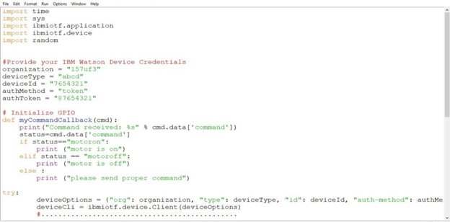

**Flow Chart**

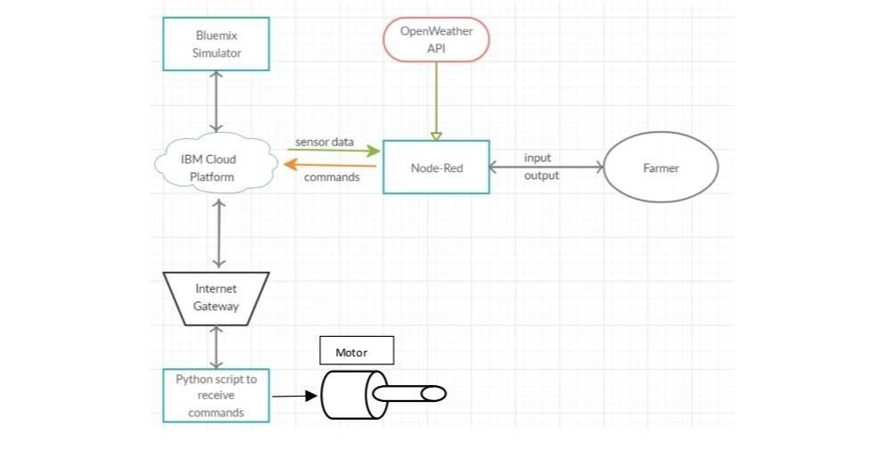

# **Observations & Results**

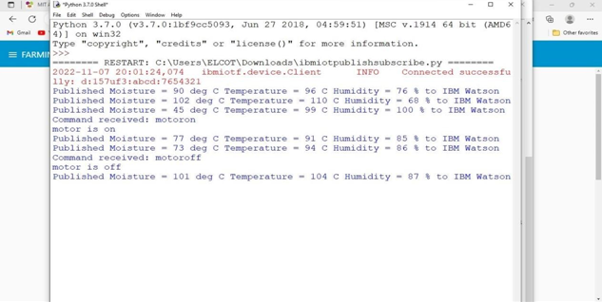

 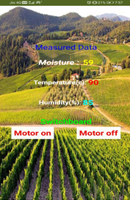

**TEMPERATURE:**

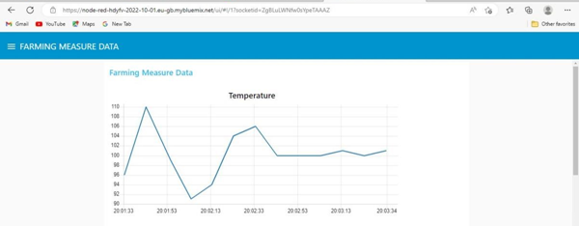

**HUMIDITY:**



**MOISTURE:**

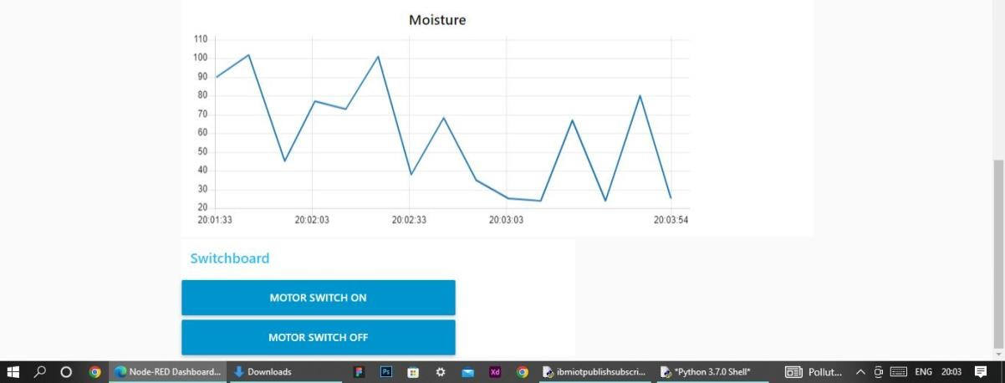

# **Conclusion:**

So to implement an IoT system in order to help farmers to control and monitor their farms has been implemented successfully.